**LEBANESE AMERICAN UNIVERSITY**

**USAID – HIGHER EDUCATION SCHOLARSHIP PROGRAM**

**HES - Volunteering Program Verification Form**

This form is to be used to document volunteering hours. If a student volunteers for multiple organizations, a separate form must be used for each organization. **This form must be turned in by the 28th of each month, the latest.**

I certify that the scholar Tasnim Abu Ismail completed a total of 10 hours of service at InnovaThrive.

The hours were completed hours as per the below:

Hours # 0 (date) _2/12 – 6/12_ (initials of supervisor) __A.K.___

Hours # 5 (date) _9/12 – 13/12_ (initials of supervisor) __A.K.___

Hours # 0 date) _16/12 – 20/12 (initials of supervisor) __A.K.___

Hours # 5 date) _23/12 - 27/12 (initials of supervisor) __A.K.___

Brief description of the activities the scholar performed or participated in:

I worked as a moderator on two researches Automation and Job Transformation andThe Influence of Social Media Influencers on Brand Perception

Written feedback about the scholar’s performance:

Tasnim demonstrated exceptional skills in reviewing and refining research on automation, job transformation, and social media's influence on branding. Her attention to detail and ability to provide constructive feedback ensured that the research was clear, accurate, and aligned with academic standards.

Please rate the overall performance of the scholar at your organization:

|  |  |  |  |
| --- | --- | --- | --- |
|  | Mastery (5) | Proficient (3) | Emerging (1) |
| **Problem solver** | X |  |  |
| **Engaged & Committed** | X |  |  |
| **Open-minded & multicultural** | X |  |  |

Signature

& stamp

__________________________

_

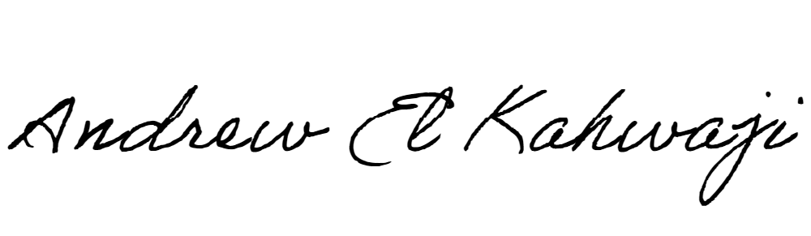

Printed Name _Andrew El Kahwaji_

Date __26/12/2024___

Email __andrew.lifesculptor.coo@gmail.com __

Phone __+961 71 914 378__